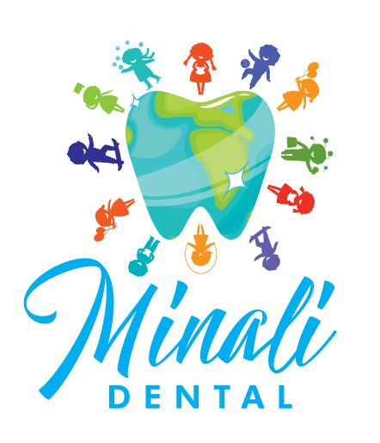

Minali Dental
Pediatric Dentist Referral
7700 Fulton St. #A
Houston, TX 77022
(832) 422-5792

Patient:_______________________________ D.O.B_____________ Patient phone# ____ ___

Referred from:_____________________________________ Date:_____________________________ _

We are referring the patient above to Mina Tabatabai, DDS the Pediatric Dentist at Minali Dental for the following reasons:

○Initial/First visit ○Parental request for a pediatric dental specialist

○Multiple cavities/extractions/space maintainer/nitrous oxide/sedation (please specify)
_____________________________________________________________________________________

○Significant medical history (please specify)_________________________________________________

○Other_______________________________________________________________________________

Thank you for your referral. We appreciate your trust in being a part of your patient’s dental care. We are looking forward to providing high quality care to the patient and will advise them to return to their dental home once treatment has been completed.

Minalidental@Gmail.com www.Minalidental.com

